## Basics

* operating system
* free
* open source

### parked topics:-

internal working of command

### History

Ken Thompson 1970s UNIX

MULTICS

UNICS

Unix

GE to AT&T

PDP 7

Dennis Ritchie C

Brian Kernigham

Linus Torvalds 1990s Linux

Richard Stallman open source

### open source

1. sell the ice cream, recipe private
2. sell the ice cream, recipe public
3. ice cream free, recipe private
4. ice cream free, recipe public

source code open

firefox

VLC

GIMP

Blender

Audacity

Wordpress

Linux

### standards

sys V

BSD

### Unix based

BSD Unix →

Next

Darwin

Solaris

AIX

HP-UX

Xenix

Free BSD

### Linux based

Red Hat

BOSS

Mint

Fedora Core

OpenSuse

Debian Linux

Ubuntu

Kali Linux

kernel

## Linux Architecture



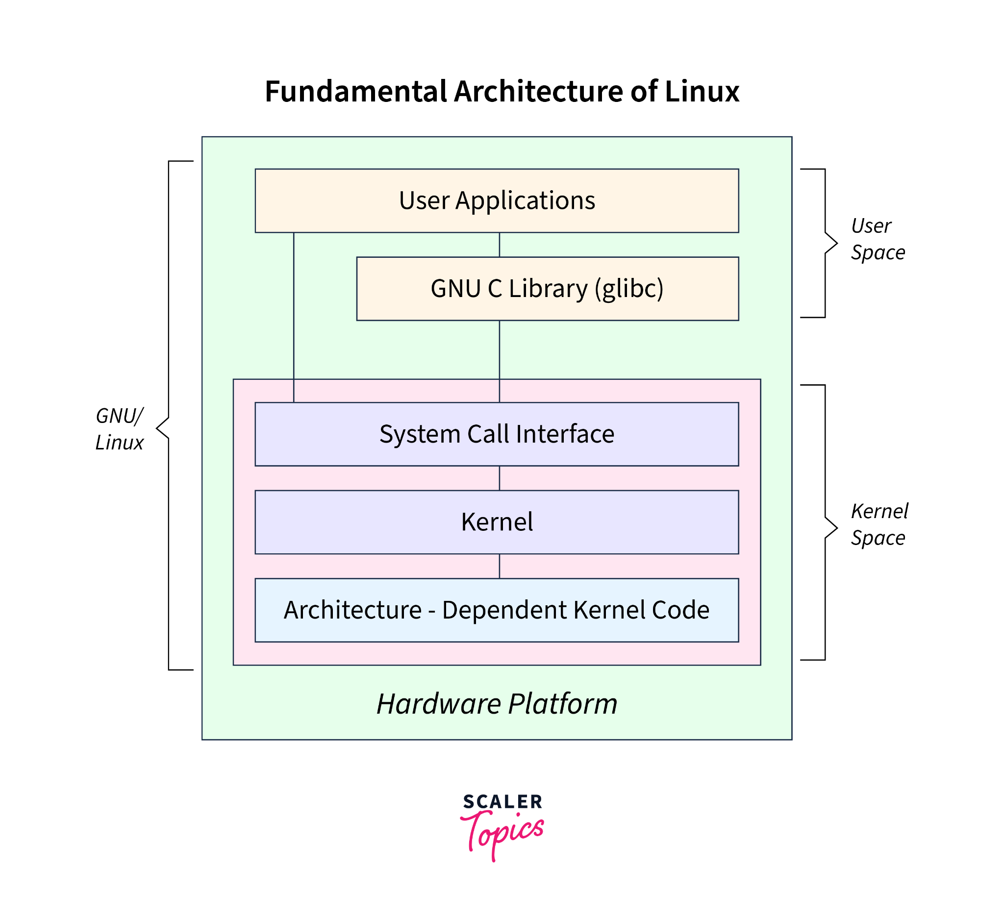

### Hardware layer

* CPU
* memory
* storage
* peripherals

### kernel layer

* process management
* memory management
* file system management
* device drivers
* network stack

### system call interface

system calls

* file operations
* process control
* IPC
* networking

### user space

#### system libraries

GNU C (glibc)

#### utilities

### shell

### user applications

* web browser
* text editors
* development tools

### File architecture

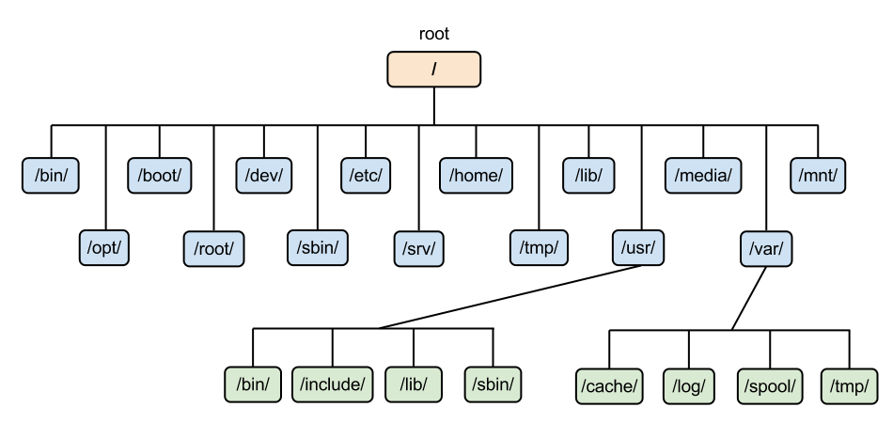

inverted tree structure

/

/home/john

/root

### init subsystem

pid 1

sysV init

traditional

/etc/inittab

/sbin/init

systemd

/etc/systemd/system

/lib/systemd/system

systemctl

### linux runlevels

0 halt the system

1 single user mode

2 multi user mode (without networking)

3 full multi-user mode with networking

4 user-defined

5 multi user mode with GUI

6 reboot the system

### boot - quick overview

BIOS/UEFI

initialise hardware

selects boot device

Bootloader (GRUB, LILO)

loads the kernel into memory

kernel initialization

hardware

mount

init/systemd

runlevel/target

login shell

## Shell

* command line interface
* cli (command line interpreter)
* terminal

sh

ksh

csh

tcsh

zsh

Fish

bash

### tcsh

csh (UNIX C shell)

tcsh

### prompt

username@hostname folder

$ normal user

>

# root

### command

command options arguments

command arguments options

* fundamental unit
* code
* executable
* spawn a new process

### builtin

* executed by shell itself
* not a new process
* (not fetching the code from somewhere else)

cd, echo, export, alias, type, history pwd

### environment variables

SHELL

LOGNAME

PATH

MANPATH

## commands

### Basic commands

ls

-a

-l

-i

-h

cd

change directory

cd Videos

.. parent

cal

-y

date

clear

bc

pwd

print working directly

### misc commands

whoami

echo $SHELL

who

touch

alias

unalias

hostname

history

shutdown

uname

whereis

which

### find

-type

f

d

-perm

-exec

-name

-iname

### pipes |

* connection mechanisms
* chaining

## help

whatis

- - help

apropos

### man

q

/text search “text”

n

shift+n

## Files & Directories

### files

* basic unit of data storage
* text files

.py

.c

.c++

.sh

* binary files

### editors

gedit

vi (vim)

nano

atom

sublimetext

vscode

emacs

notepad++

### view

cat

nl

less

more

head

tail

most

### other commands

cp

copy

mv

move (cut & paste)

rename

rm

remove (delete) file/directory

-i interactive

-f force

-r recursive

wc

-l

-c

-w

### directories

* relative paths
* absolute path
* home directory for every user

cd

<dir>

.. parent

. current directory

~ home directory

mkdir

make directory

rmdir

remove a directory

only empty directory

### inode

* unique identifier for every file in the storage

ls -i

### file descriptor

* temporary number
* lowest possible number

### types of files

regular files

-

directory

d

symbolic links

l

character device files

c

block device files

b

named pipes (fifos)

p

sockets

s

## vi

vim

insertion mode

i

command mode

esc

### commands

:w save (write)

:w! save as

:q! quit without saving

:wq save & quit

dd cut

delete

3dd cut 3 lines

p paste

yy copying

u undo

ctrl+r redo

### redirection

>

>> append

## user & groups

* home directory for every user
* uid
* gid

yearly_trainings.data

| permissions | | |
| --- | --- | --- |
| user | group | others |
| john | training | others |
| read write ~~execute~~ | read write ~~execute~~ | read ~~write execute~~ |
|  |  |  |

### superuser

root #

### modes

| user | group | others |
| --- | --- | --- |
| r w - | r w - | r - - |
| 1 1 0 | 1 1 0 | 1 0 0 |
| 6 | 6 | 4 |
| u | g | o |

filea.txt 664

666

chmod +w

chmod o+w

chmod 0666 filea.txt

### commands

chmod

chown

chgrp

useradd

passwd

groupadd

usermod

-G groupname

groups

groups username

id username

## scripting

.rc

configuration files

resource control

(run commands)

## wild cards

* any number of characters

zero or more

? single character

[ ] single character

can be chosen from multiple options

range

## grep

* finds a pattern
* n
* i
* v

find → names(paths) of files

grep → “pattern” in the name (path) of the file

### xargs

find ~/Desktop/liftoff/ -type f -mtime -1 | xargs grep -i "ringo"

### regex

metacharacters

^ start of the line

$ end of the line

. one character placeholder

* zero or more occurrences

[ ] multiple options

range of options

#### extended regex

? zero or one occurrences

+ one or more occurrences

| alternation

( ) grouping

{ } repetition

## links

1. hard links
2. symbolic (soft) links

## all commands

pwd

ls

cal

bc

date

whatis

man

apropos

clear

mkdir

rmdir

cd

cp

mv

rm

cat

head

tail

more

most

less

nl

su

who

whoami

useradd

groupadd

passwd

usermod

chmod

chown

chgrp

id

groups

touch

alias

unalias

hostname

history

shutdown

uname